**Project Overview**

Project name: Sponsorship management

Project goals:

1. To provide a collective database of potential and current sponsors along with contact information, organized by respective sectors.
2. A hierarchy of access, modelled on the existing Sponsorship team structure:
   1. Top-level: Chief Sponsorship Officer (admin)
   2. Mid-level: Sector Head(s)
   3. Entry-Level: Sponsorship Representatives
3. To facilitate efficient collaborative effort between members of the sponsorship teams, by providing a common database which stores:
   1. Updates on the real-time status of the sponsor companies.
   2. Name, contact information of the key personnel in the sponsoring companies.
   3. A log of meetings held with sponsorship team members and potential sponsors, organized by sector.
4. A reporting feature of the amount of sponsorship received on a real-time basis:
   1. A reporting of the total amount received.
   2. A sector-wise total reporting of the Sponsorship amounts.
   3. A company-wise breakup of Sponsorship amounts.
   4. A reporting feature of the amount of sponsorship brought by each individual SponsRep or SectorHead.

Corresponding reports can only be viewed by users with the appropriate authorization level.

Interfaces provided:

1. Sponsorship Representative (SponsRep):
   1. View, Insert, Update, Delete details of Companies of that sector from Company Table
   2. View, Insert, Update, Delete details of Company Executives from CompanyExec Table for that sector
   3. View, Insert, Update, Delete details of meetings of other sponsreps from that sector from Meeting table. This should be used to see which fellow sponsreps are meeting with which companies, to avoid conflicts.
   4. View and Insert personal entries into Festival Account table on receiving a sponsorship from a company. Cannot view entries of other sponsreps in sector.
2. Sector Head (SectorHead):
   1. View details of any SponsRep in his sector, transfer them to other sectors (cannot insert SponsReps).
   2. View, Insert, Update, Delete details of Companies of that sector from Company Table
   3. View, Insert, Update, Delete details of Company Executives from CompanyExec Table for that sector
   4. View, Insert, Update, Delete details of meetings of all sponsreps from that sector from Meeting table.
   5. Insert personal entries into Festival Account table on receiving a sponsorship from a company. SectorHeads can view account entries of all SponsReps in his sector, but not other sectors. SectorHeads can delete account entries of any sponsrep in his sector, but not other sectors.
3. Chief Sponsorship Officer (CSO):
   1. Admin access.
   2. View details of any SponsRep, insert SponsRep details including name, mobile, email, year, branch and sector and, transfer them to other sectors, update their passwords.
   3. View details of any SectorHead, insert SectorHead details including name, mobile, email, year, branch and sector and, transfer them to other sectors, update their passwords.
   4. View, Insert, Update, Delete details of Companies of any sector from Company Table
   5. View, Insert, Update, Delete details of Company Executives from any sector in CompanyExec Table
   6. View, Insert, Update, Delete details of meetings of all sponsreps from Meeting table.
   7. View all AccountLog entries, see total earned by all sectors, delete any account entry.

Data Flow Diagram:

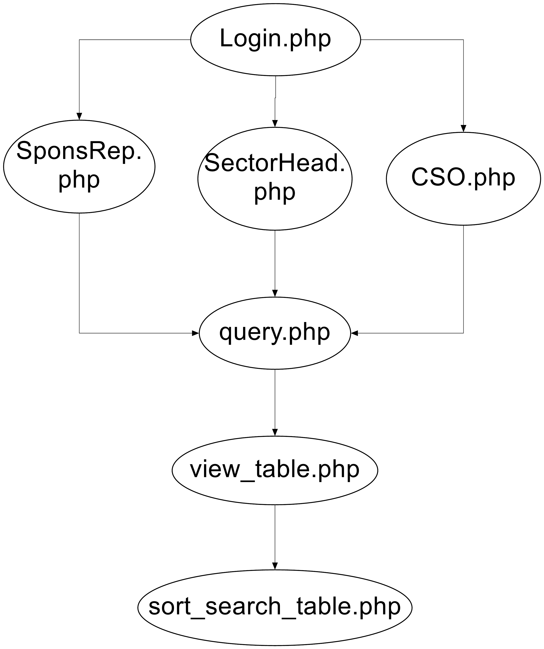

Access Hierarchy Diagram:

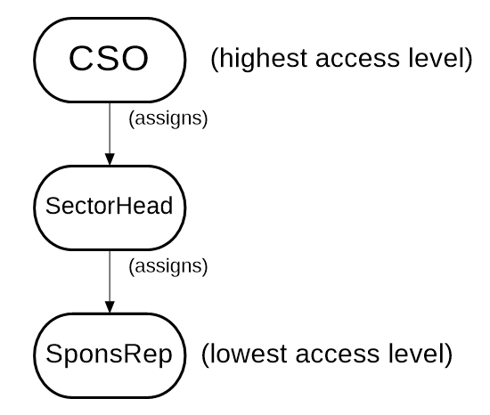

Steps to use the system:-

1) Go to the link : 172.18.61.58/xampp/sponsorship/SMP

Enter the xampp username and password:

Username : xampp

Password : adminsys@Xampp321

**OR**

go to link:

http://sponsorshipmanagement.netau.net/SponsMan%20full%20script/login.php

2) Enter the username and password for both the end users i.e. sponsorship students

1. For SponsRep:

SponsID: 131080008

Password: 131080008testing

2. For SectorHead:

SponsID: 121080001

Password:  121080001test

3. For CSO:

SpondID: 131080051

Password: ardivekar

Team members:

131080051 – Abhishek Divekar

131080053 – Advik Shetty

131080055 – Janit Mehta

INSTALLATION GUIDE FOR THE SYSTEM:

Following are the steps to install our system on some server :

Since we have developed a web application using web languages such as PHP, HTML and JavaScript, the user does not has to install some package or software to set up the system.

The steps required to set up the system are:

1. You must have a server and a file manager installed on your computer.

2. Open the file manager and connect to the server.

3. Drag the folder – sponsorship into the file manager.

4. To create the database execute these files in order:

1. Spons Database Drop Tables.php
2. Spons Database Generate Tables.php
3. Spons Database Populate Tables.php

6. Consider the IP address as 172.18.61.58

And you have saved the files in the directory whose path is sponsorship/SMP

Now to use the system you will have to enter the given url :

<http://172.18.61.58/xampp/sponsorship/SMP/>

7. The above URL will direct you to the login page of the system and then you can access the whole system whenever you need to. If it does not do so, go to <http://172.18.61.58/xampp/sponsorship/SMP/login.php>

8. To access the system on some other computer on the same server you just have to enter the URL that was specified in step 6.

Thus by following the above steps you can install and setup the system on your local computer

USER MANUAL:

Login page

This is the first page seen by the end-user. Here, you are prompted to enter your Sposorship ID and password, which must be assigned by the Chief Sponsorship Officer (CSO) beforehand. CSO is the admin of this database.

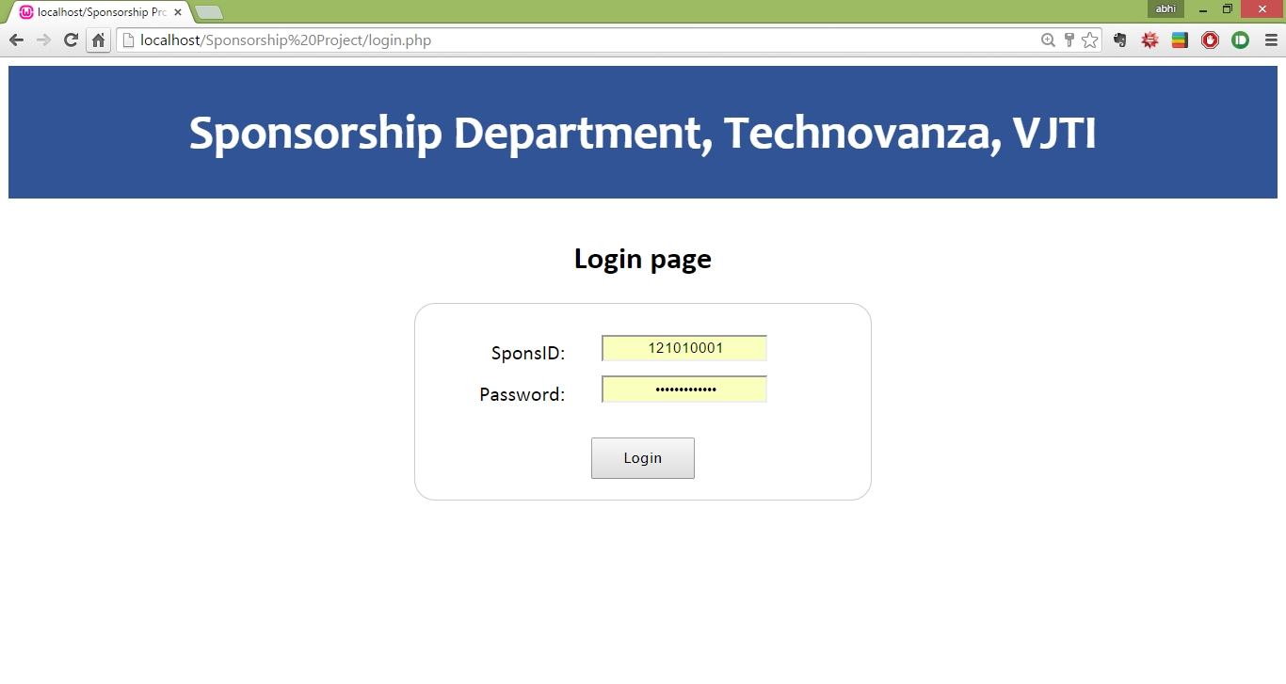

Users entering incorrect login credentials will not be permitted access to the database.

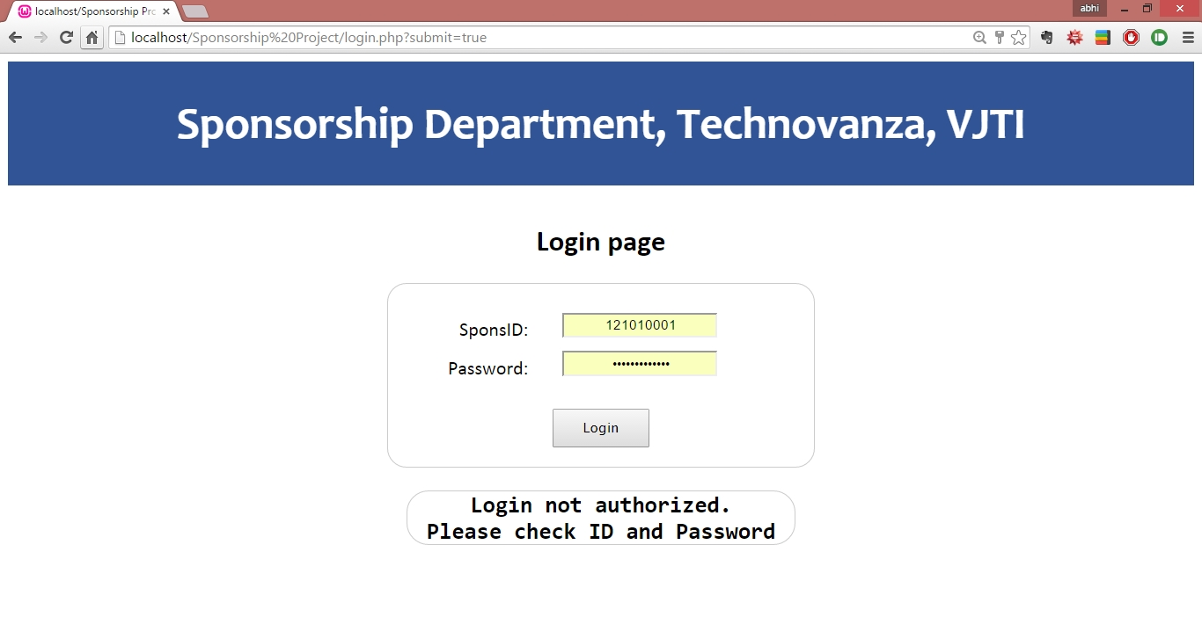

For a successful login, depending on the login credentials, the login page redirects to the appropriate page:

* Sponsorship Representatives are redirected to sponsrep.php
* Sector Heads are redirected to sectorhead.php
* The CSO is directed to CSO.php

These pages represent the authorization structure into which the database is divided. They are organized in a hierarchy.

Different authorization levels provide access to different tables functionality of the database.

Example home page:

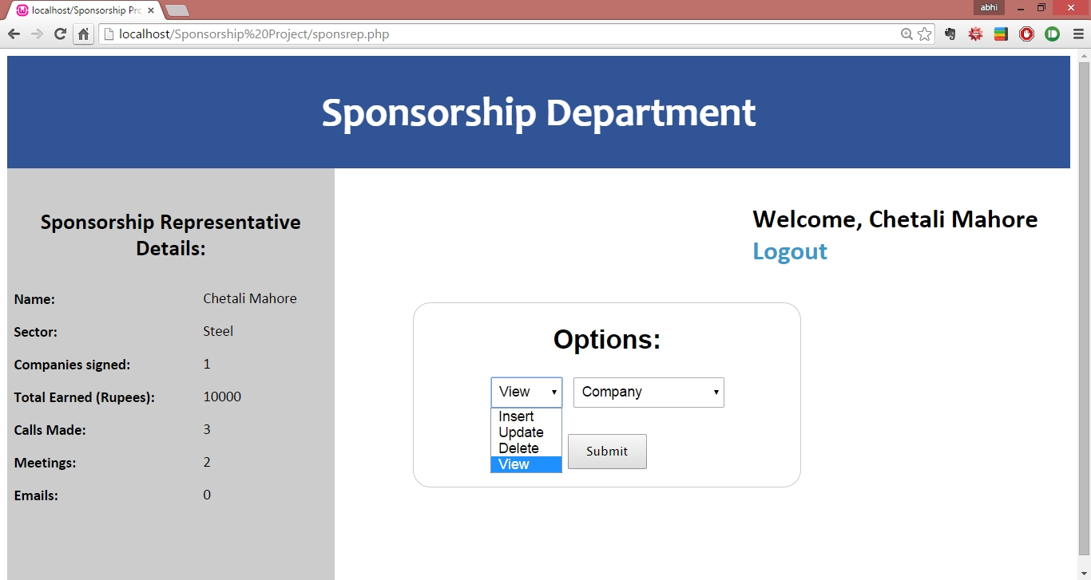

In each of these pages, we have a left overview pane, which provides immediate access to important data. This is queried every time the page is loaded and thus is useful for providing an overview of the most relevant information.

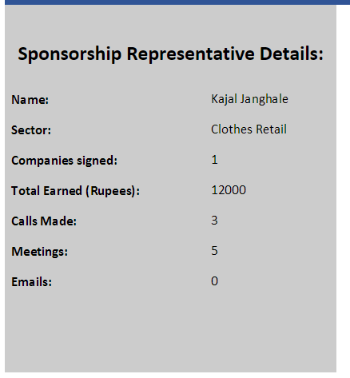

If one wishes to gain more information, then there is an ‘Options’ tab which allows us to get more precise data from the various tables in the database, by using the ‘view’ function.

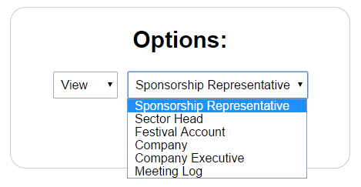

This redirects us to one of the view_table pages:

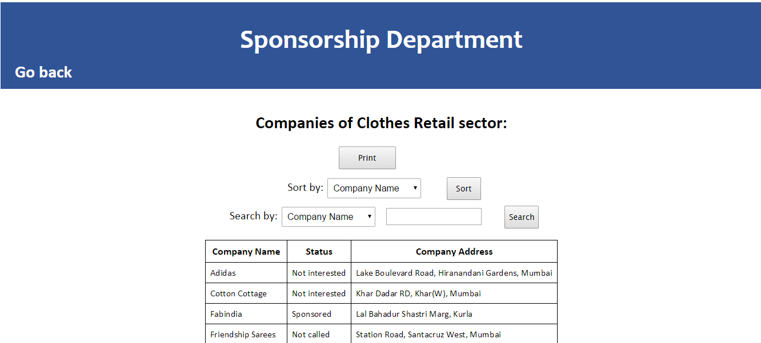

Inside this page, we can search or sort by the attributes of the tables:

1. Sorting:  
     
   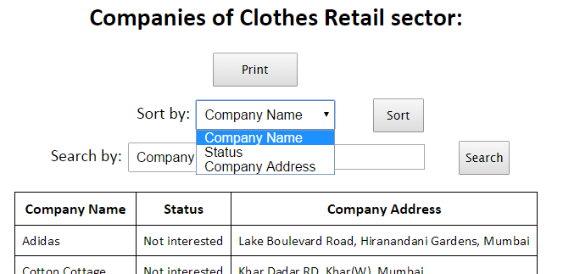
2. Searching:

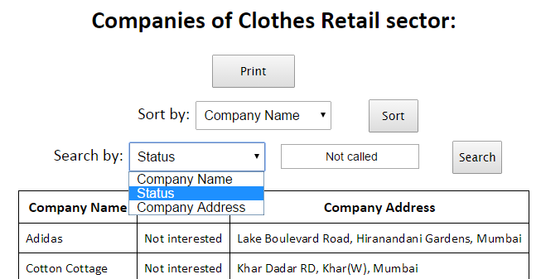

If we require a printout, we can press the print button:



Which redirects us to the print panel:

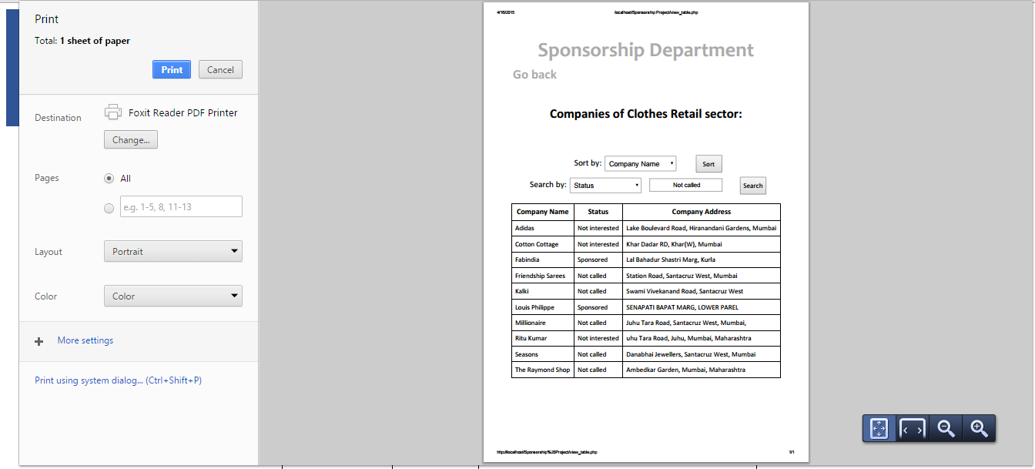

To go back to the home screen, we can press the go back button in the top left:



This will redirect us to sponsrep.php, sectorhead.php or CSO.php, as per our requirement, where we shall still be logged in.

We can then view other tables.

The ‘Options’ form also allows us to insert, update, delete, or view information of the tables which the user has access to.

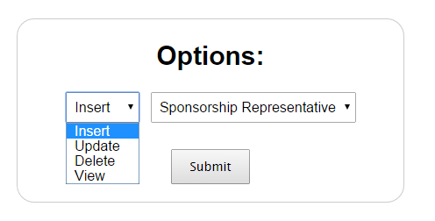

Here, depending on our selection, we get an insert, update or delete form.

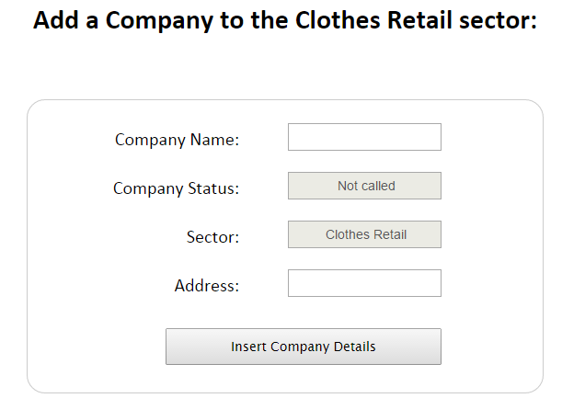

If we are not authorized to insert, update or delete from that table, we get an error:

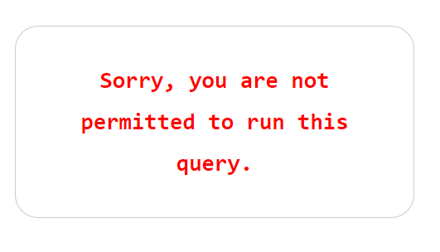

Finally, we can logout with the logout button on the top right of the home page.



1. SponsRep page:

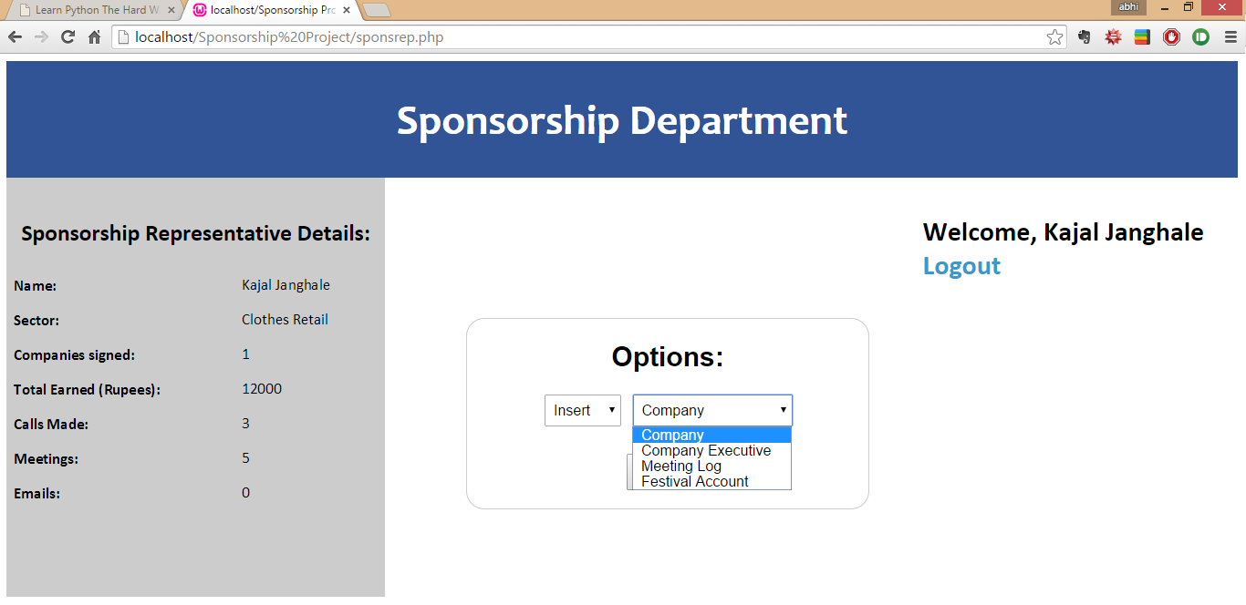

This is the homepage of the Sponsorship Representative.

On the left is an overview of the Sponsorship Representative, which includes:

* The name of the sponsorship representative
* The sector to which he/she belongs, currently
* “Companies signed”, i.e. the number of sponsorships received (i.e. entries in the AccountLog table).
* The total earned by that Sponsorship representative.
* The number of calls made with executives of different companies.
* The number of face to face meetings with executives of different companies.
* The number of emails sent to executives of different companies.

A SponsRep has access to the following tables:

* Company: A SponsRep is allowed to access, insert, update and delete information of potential sponsoring companies **from his sector only**. As we progress with the sponsorship process, the status flag of a company is often updated, and tells us if the company is interested or not (the default is “not contacted”).
* Company Executive: A SponsRep is allowed to access, insert, update and delete information of potential sponsoring companies **from his sector only**.
* Meeting Log: A SponsRep logs meetings made with various company executives of various companies in his sector, into a common meeting log which is shared by all SponsReps in the sector.

The purpose of this meeting log is to prevent unnecessary contacting of companies. SponsReps should log their meetings with a particular, and thus inform the other SponsReps that they are going to meet/call their company in the future.

After a meeting is completed, the SponsRep should update the outcome of the meeting, for later reference for himself and fellow SponsReps. At this point the company status also may need to be updated.

* Festival account: if a SponsRep had managed to acquire a sponsorship grant from a company, then he/she must log it into the AccountLog. However, for purposes of security, the SponsRep only has access to his own entries in the AccountLog.  
  Festival entries also cannot be deleted by SponsReps, they can only be deleted by their respective SectorHeads.

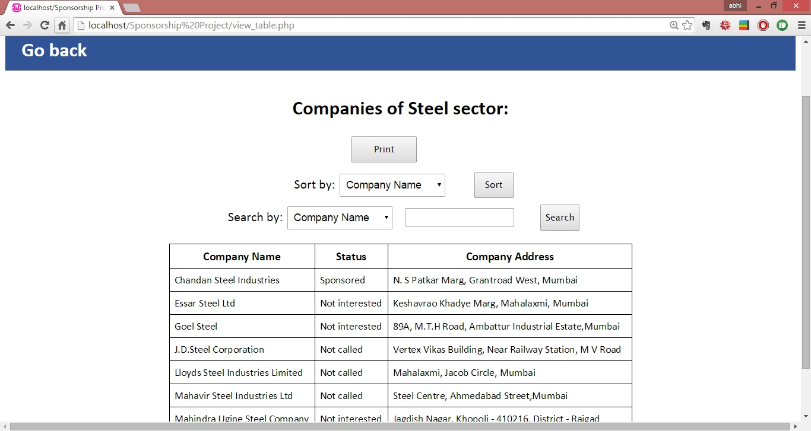

Sponsorship Representatives can view companies from his own sector only.

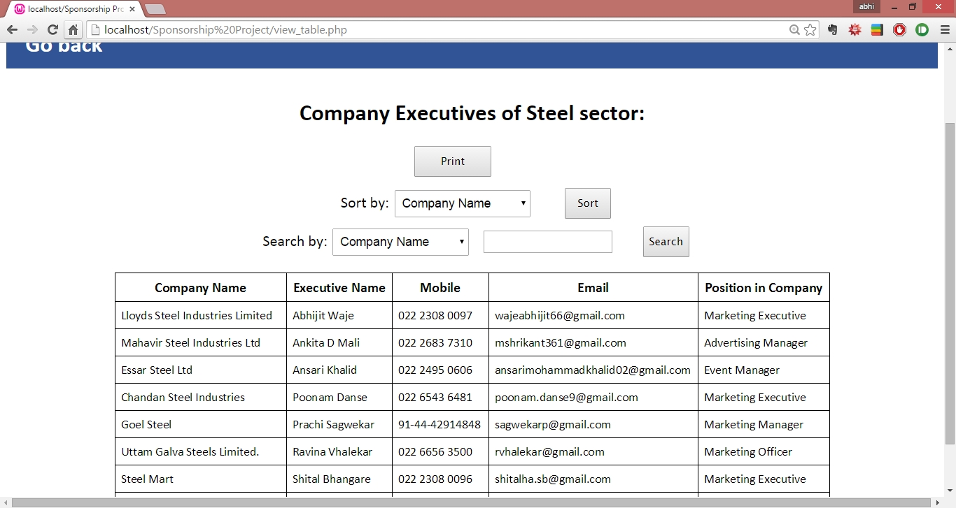

Sponsorship Representatives can view company executives from his own sector only.

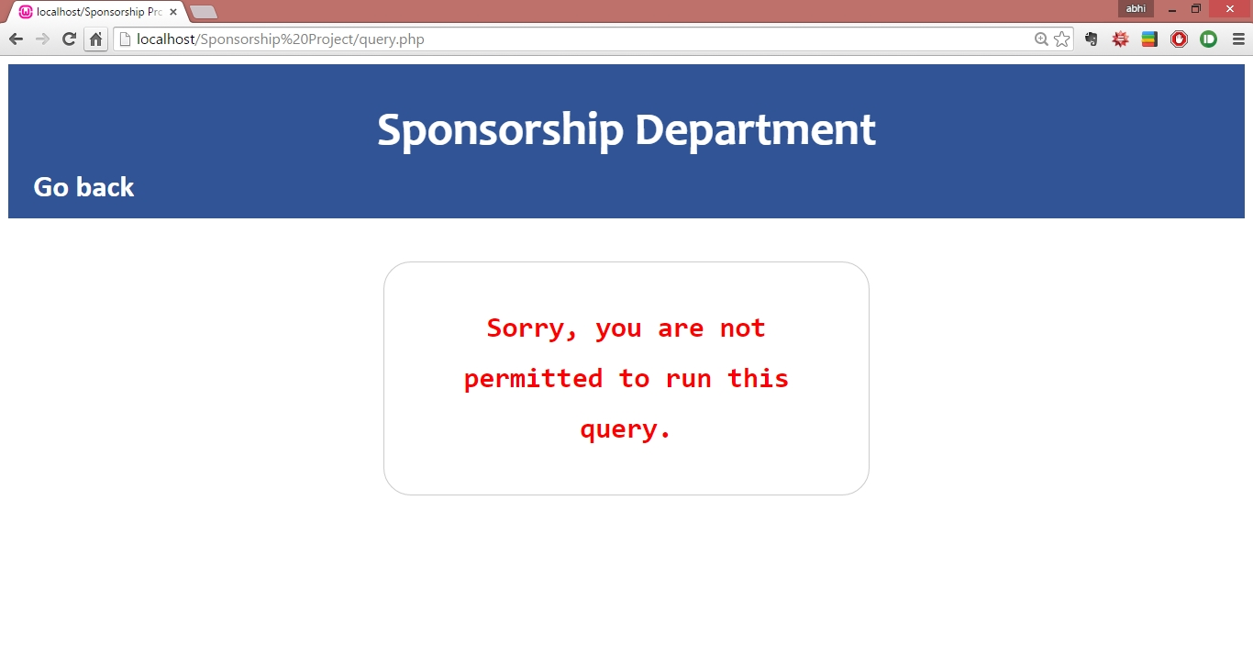

Sponsorship Representatives can’t view anything from the sector head table even if he is from the sector.

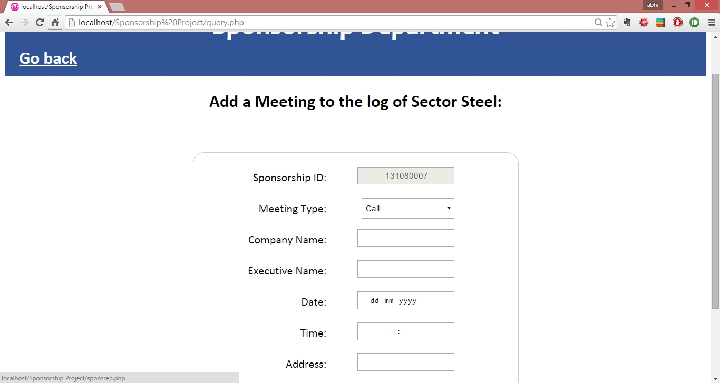

Sponsorship Representatives can add into Meeting logs

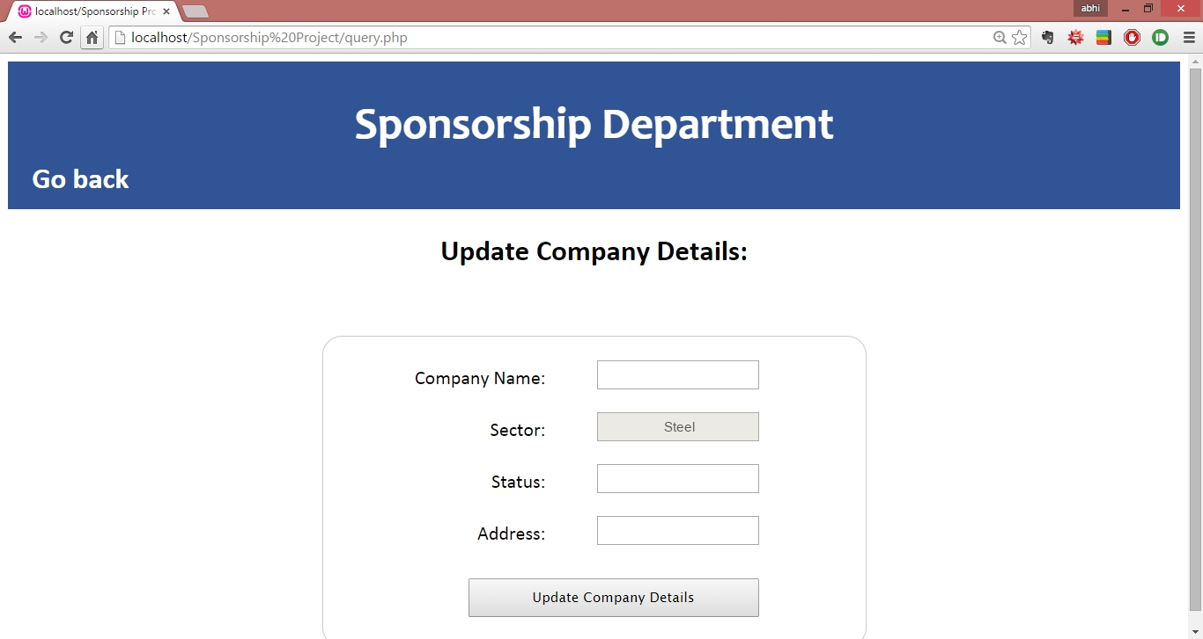

Sponsorship Representatives can only update companies from his own sector.

1. SectorHead page:

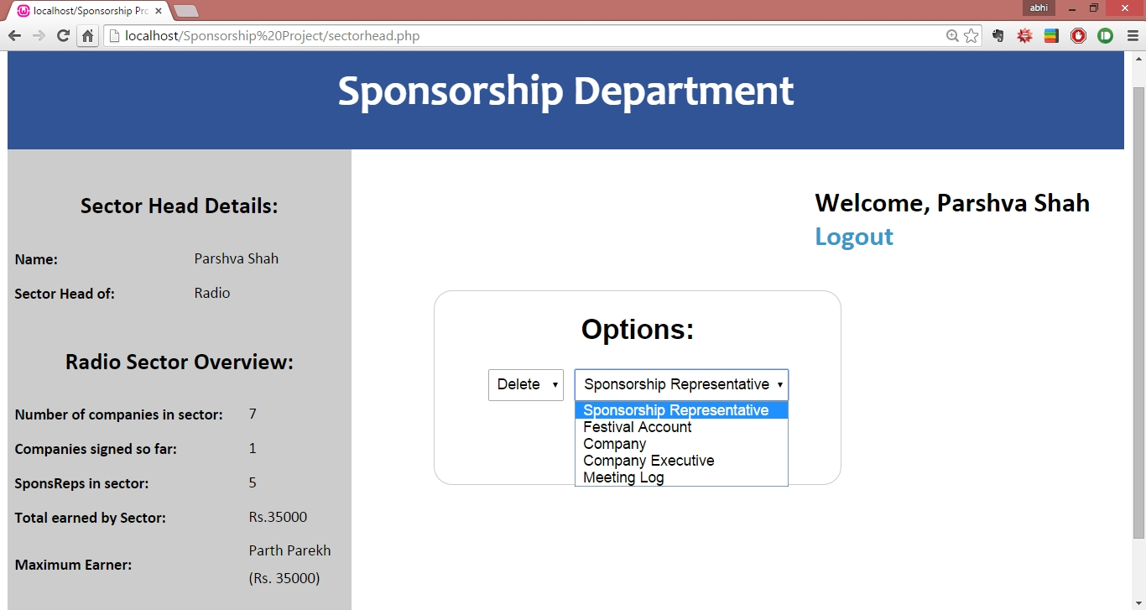

This is the homepage of the Sector Head.

On the left is an overview of the Sector Head, which includes:

* The name of the sector head.
* The sector to which he/she heads, currently
* Total no. of Companies in the sector
* Total no. of “Companies signed”, i.e. the number of sponsorships received (i.e. entries in the AccountLog table) by the sector.
* The total earned by that sector.
* The maximum earner in the sector.
* A Spector head has access to the following tables:
* Company: A SectorHead is allowed to access, insert, update and delete information of potential sponsoring companies **from his sector only**. As we progress with the sponsorship process, the status flag of a company is often updated, and tells us if the company is interested or not (the default is “not contacted”).
* Company Executive: A SectorHead is allowed to access, insert, update and delete information of potential sponsoring companies **from his sector only**.
* Meeting Log: A SectorHead logs meetings made with various company executives of various companies in his sector, into a common meeting log which is shared by all SponsReps in the sector.

The purpose of this meeting log is to prevent unnecessary contacting of companies. SectorHead should log their meetings with a particular, and thus also inform the other SponsReps that they are going to meet/call their company in the future.

* Festival account: if a SectorHead had managed to acquire a sponsorship grant from a company, then he/she must log it into the AccountLog. However, for purposes of security, the SponsRep only has access to his own entries in the AccountLog.  
  Festival entries also cannot be deleted by SponsReps, they can only be deleted by their respective SectorHeads.
* Sponsorship Representatives : A SectorHead is allowed to access, insert, update and delete information of Sponsorship Representatives **from his sector only.**

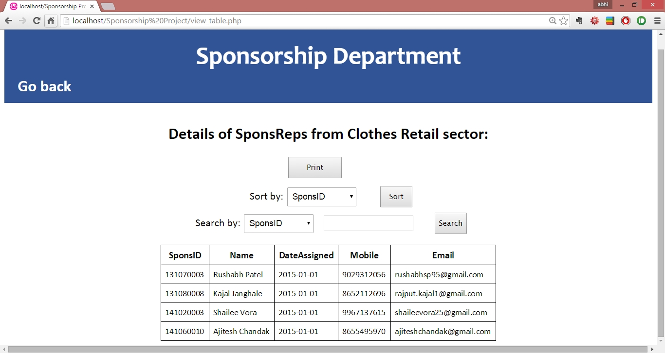

The sector head can view all the SponsReps in his/her sector

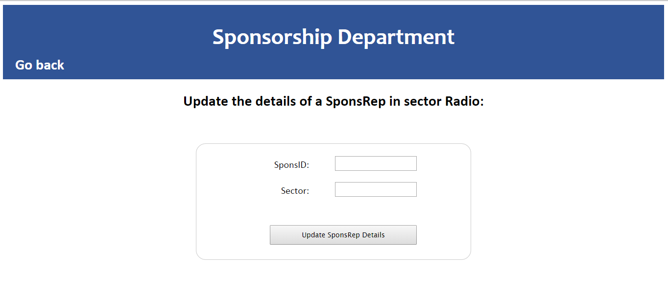

The sector head can reassign SponsReps in his/her sector to other sectors.



Sector Head can view companies from his own sector only.



Sector head can view company executives from his own sector only.



Sector head can add into Meeting logs in his/her own sector, with only his/her ID.



Sector head can only update companies from his/her own sector.

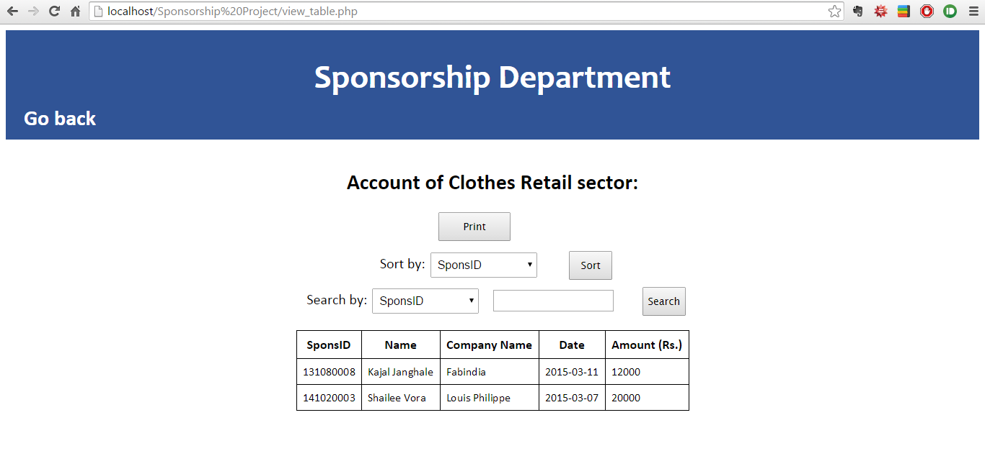

Sector heads can view the account entries of ALL sponsreps in the sector.

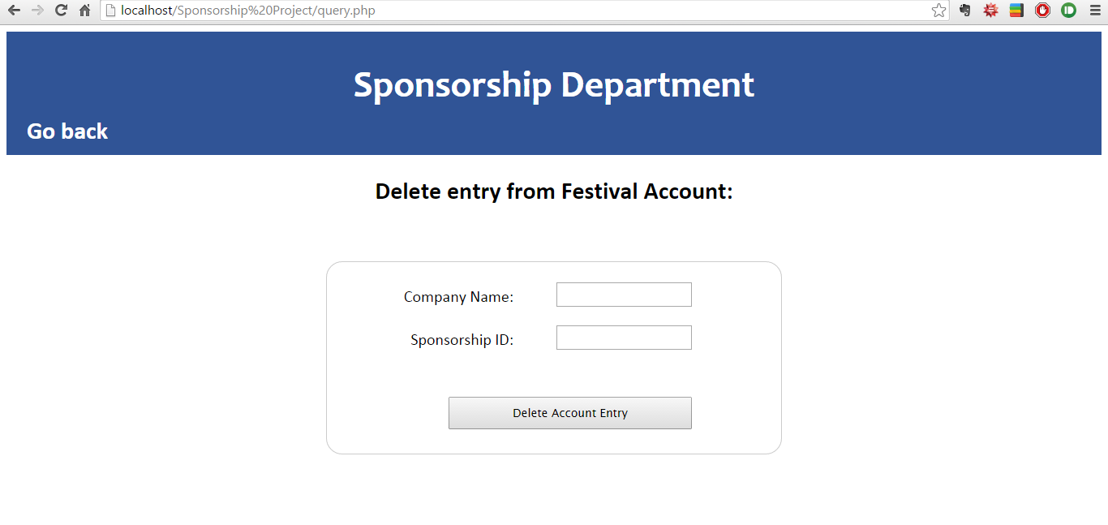

Sector heads can delete an account log entry of any sponsrep in his sector.

1. CSO page:

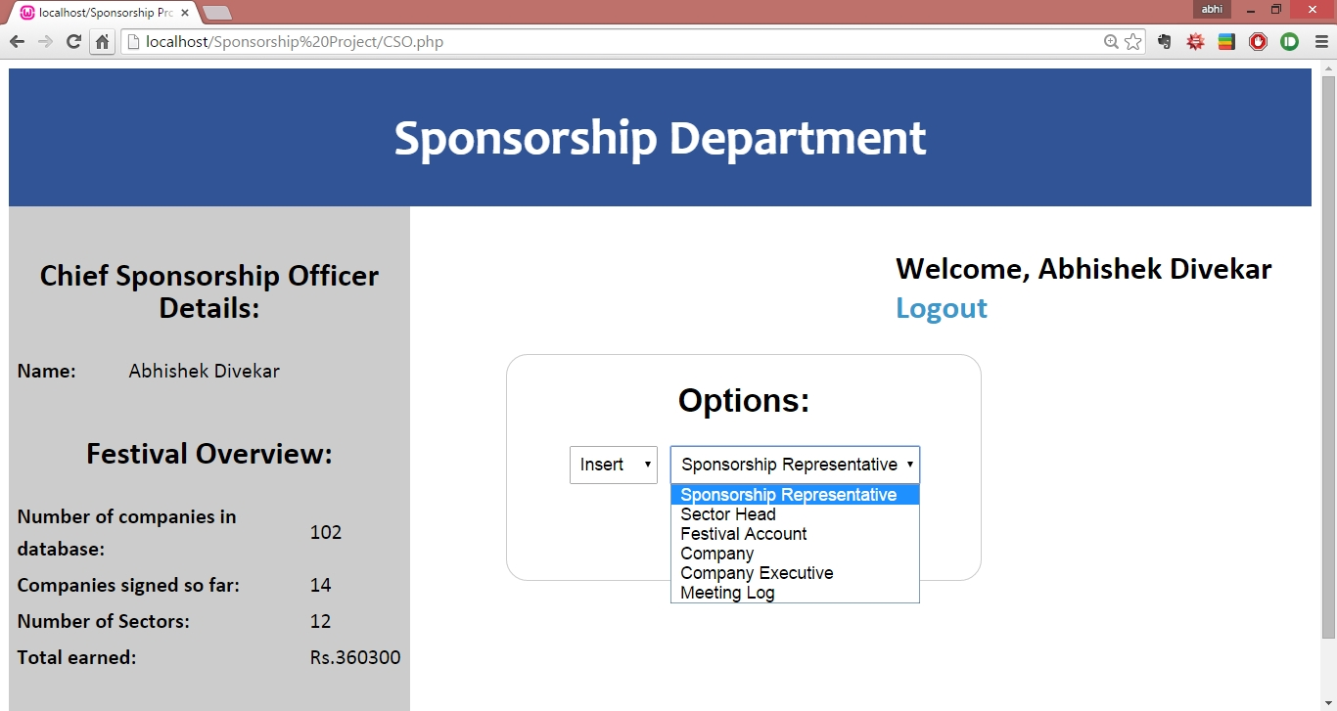

This is the homepage of the Chief Sponsorship Officer(CSO). On the left is an overview of the Sponsorship Department- Number of companies in the database, number of sector, companies signed so far and total amount collected by the whole sponsorship department

Chief Sponsorship Officer Functionalities:-

* Insert, Update, Delete, View **Companies**
* Insert, Update, Delete, View **Company Executives**
* Insert, Update, Delete, View entries from **Meeting Log**
* Insert, Delete, View items from **Account Log**
* Insert, Update, Delete, View **Sponsorship Representatives**
* Insert, Update, Delete, View **Sector Heads**

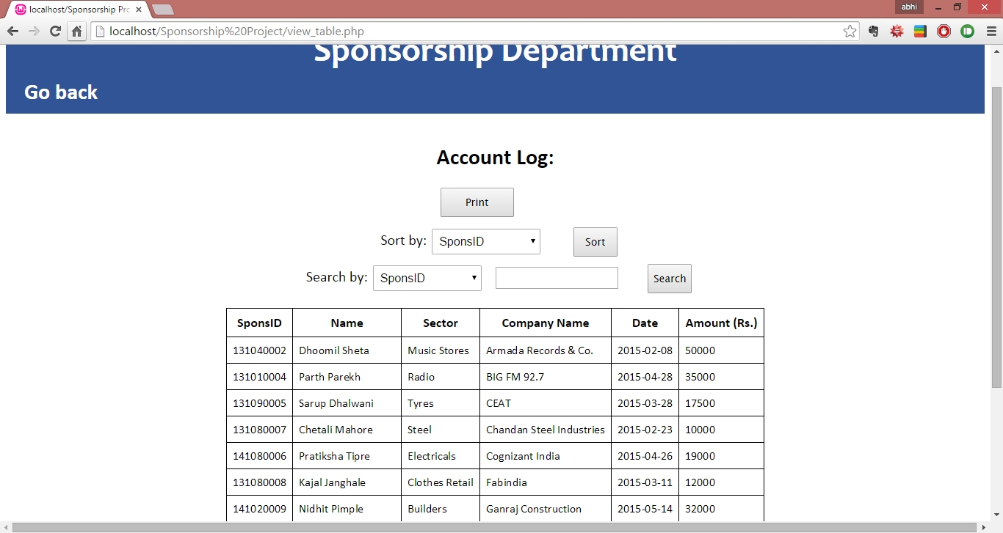On choosing view Account Log, this is the output displayed.

It is the Account log for the entire festival, containing entries of sponsreps from all sectors. The user can search, sort and print the table.

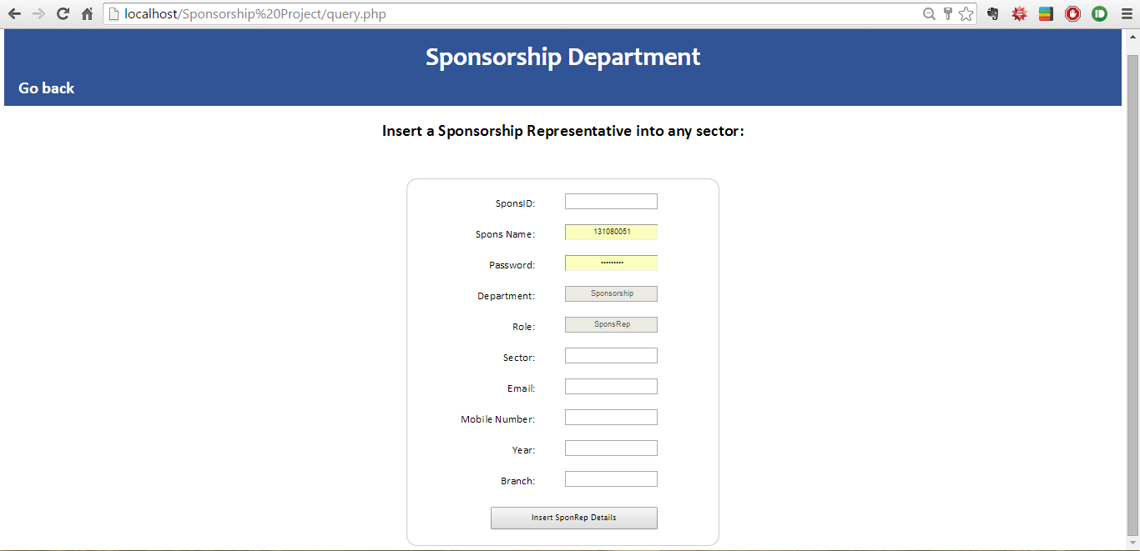

Only the CSO can insert into the SponsRep and SectorHead tables. This is the only place where we make entries into CommitteeMember, and where we can set the mobile, email, password etc.

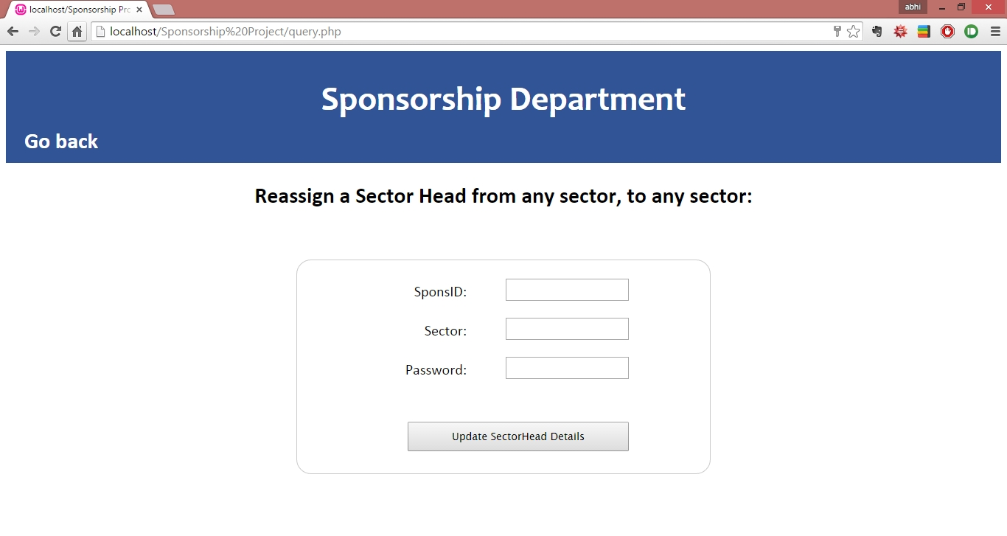

If update sector head or sponsrep is selected, this form is displayed. The SponsID of the sector head to be reassigned needs to be entered with the desired change – Sector or Password. If only sector needs to be changed, then password can be left blank, similarly for password. But **both cannot** be left blank.

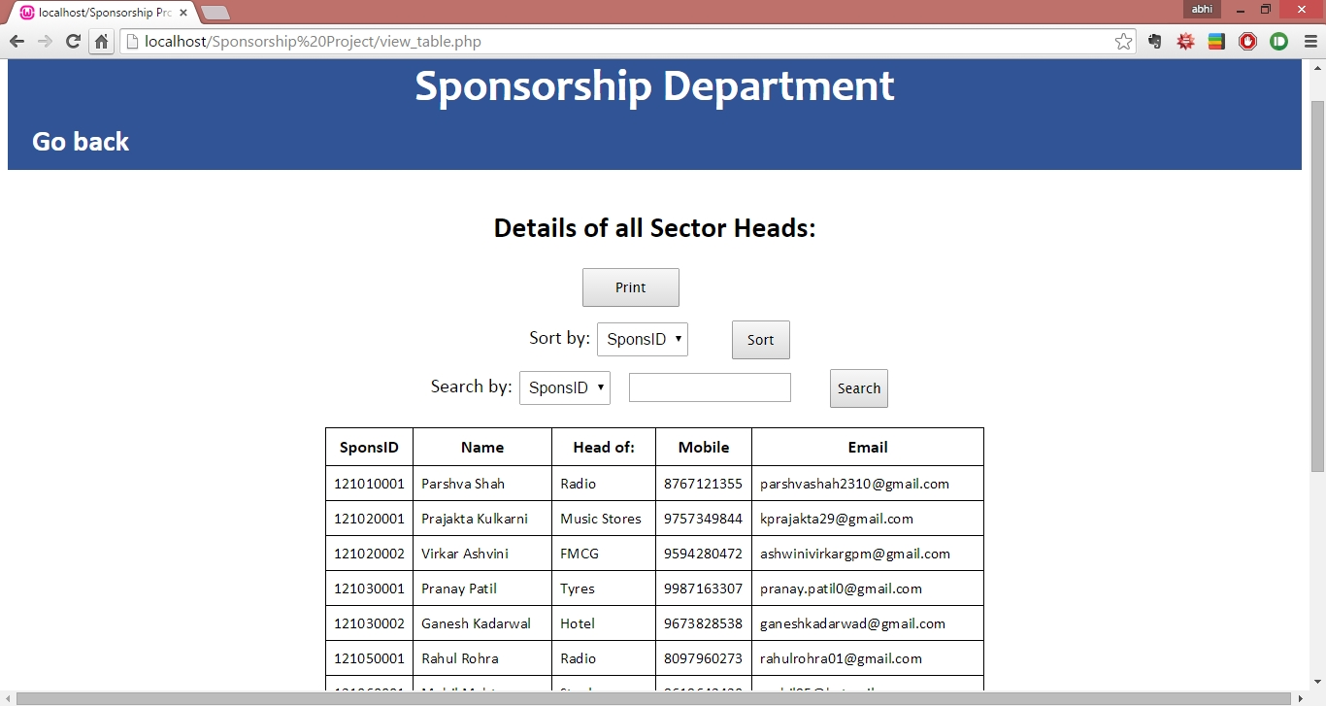

On updating the details of the sector head, or selecting view sector heads from the CSO homepage. This table is displayed which can be sorted, searched and printed

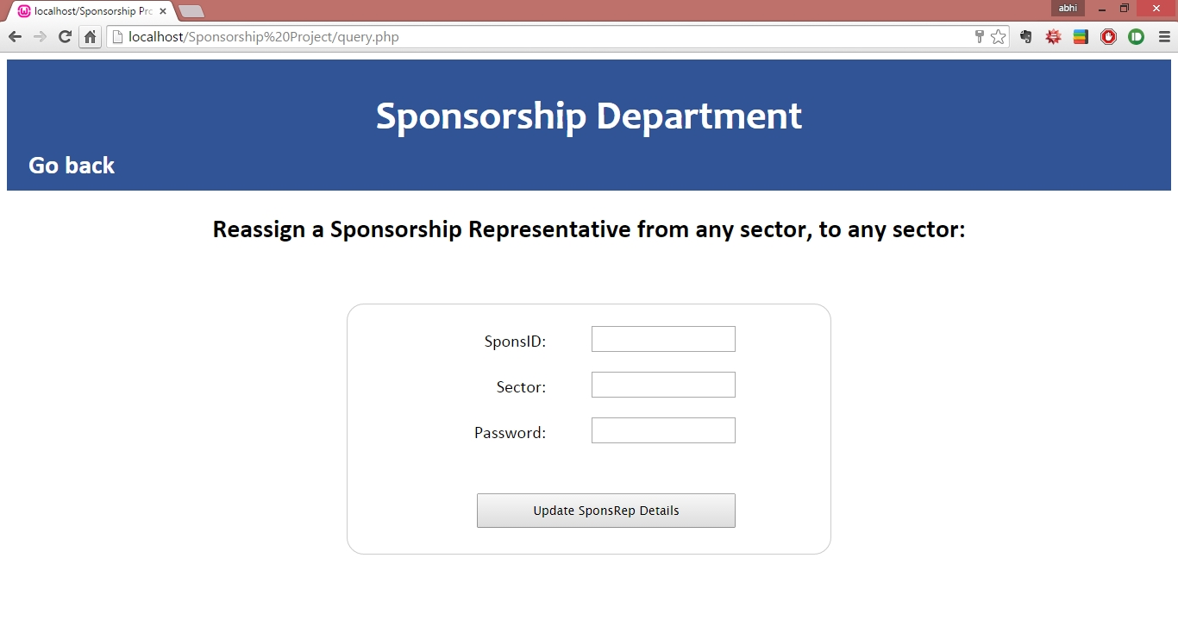

If update sponsorship representative is selected, this form is displayed. The SponsID of the sector head to be reassigned needs to be entered with the desired change – Sector or Password. If only sector needs to be changed, then password can be left blank, similarly for password. But both cannot be left blank

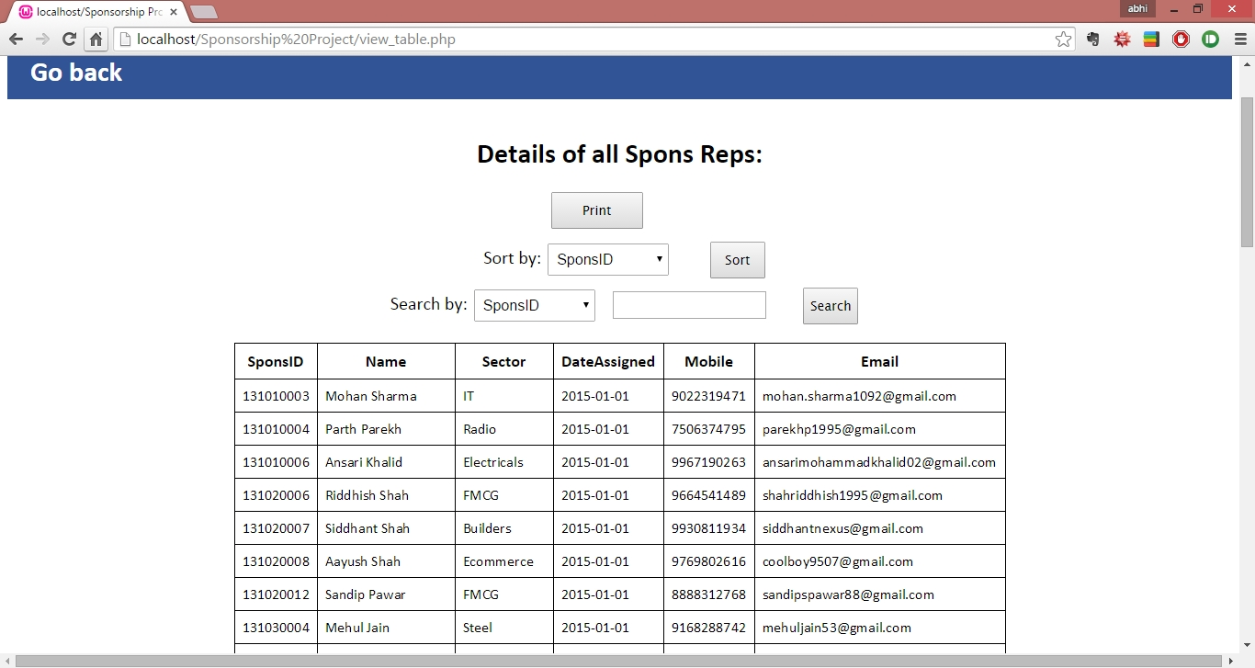

On updating the details of the Spons Reps, or selecting view Spons Reps from the CSO homepage. This table is displayed which can be sorted, searched and printed.

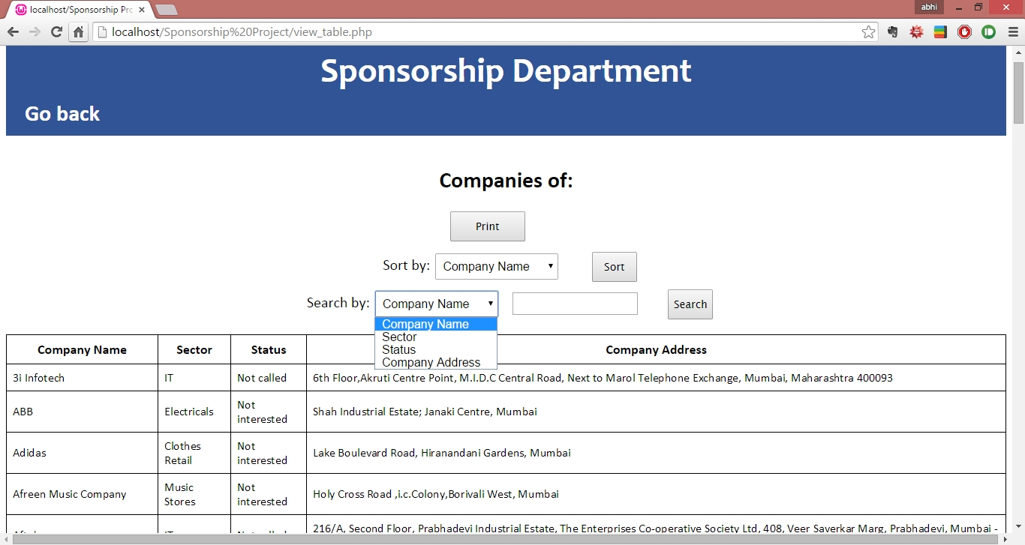

On updating the details of the companies, or selecting- view companies from the CSO homepage. This table is displayed which can be sorted, searched and printed.

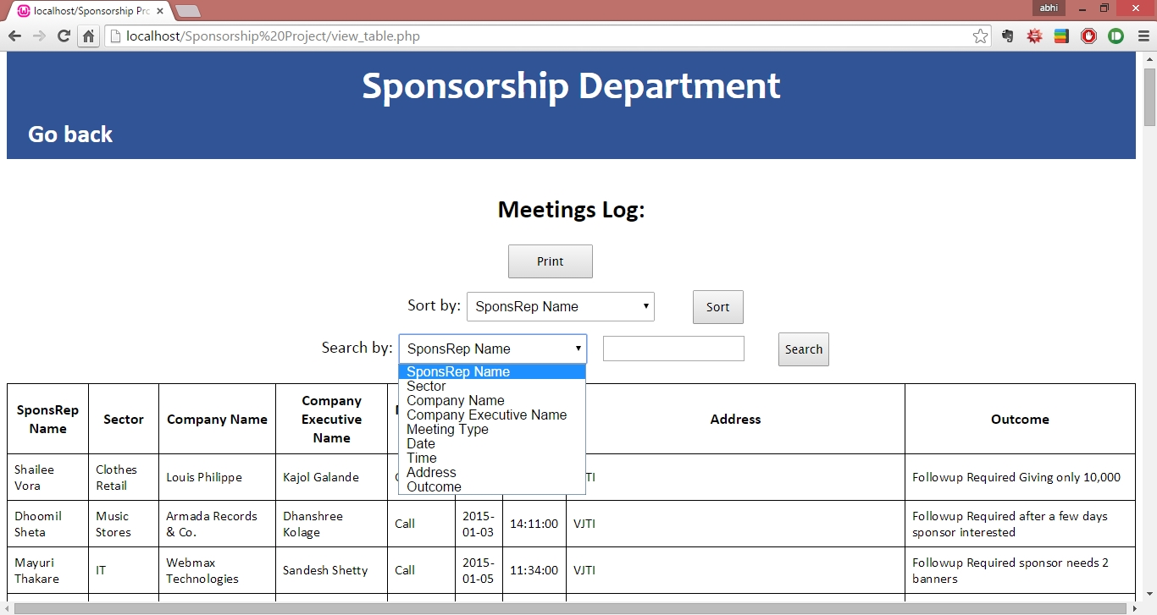

On updating the details of the meeting log, or selecting view- meeting log from the CSO homepage. This table is displayed which can be sorted, searched and printed.

ER diagram:

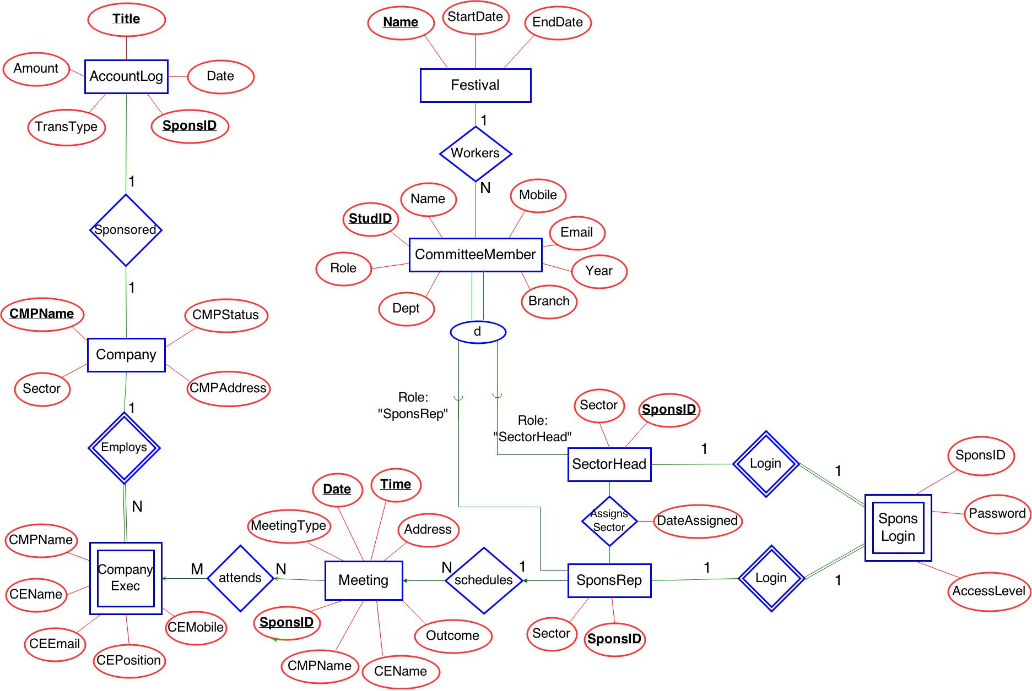

**Database script:**

To create database and insert data execute the given files:

1. Spons Database Drop Tables.php
2. Spons Database Generate Tables.php
3. Spons Database Populate Tables.php

**GUI script:**

To use the entire system execute the given link:

<http://172.18.61.58/xampp/sponsorship/SMP/login.php>

User Review:

SponsReps:

Resolved:

* ***Feature to sort table of results by **any** attribute
* ***Feature to search for value of **any** attributes in table of results
* Back button positioning resolved
* Expanded attributes of view pages for MeetingLog and Festival account.
* Ability to search by any company name
* Ability to sort meetings by date.

Future Work:

* Add reminders on the sponsrep and sectorhead home pages for upcoming meetings.

SectorHead:

Resolved:

* ***Feature to sort table of results by **any** attribute
* ***Feature to search for value of **any** attributes in table of results
* Printing report of table of results for sponsrep, festival account and meeting log.

Future Work:

* Update festival account entry (as of now we must delete and insert new).
* Expanded views, merging of multiple views for convenience.

CSO:

Resolved:

* Display of all sponsreps not working
* Now allows insertion of email, name etc.
* Allows updating passwords.

Future work

* Query box for CSO.

SectorHead:

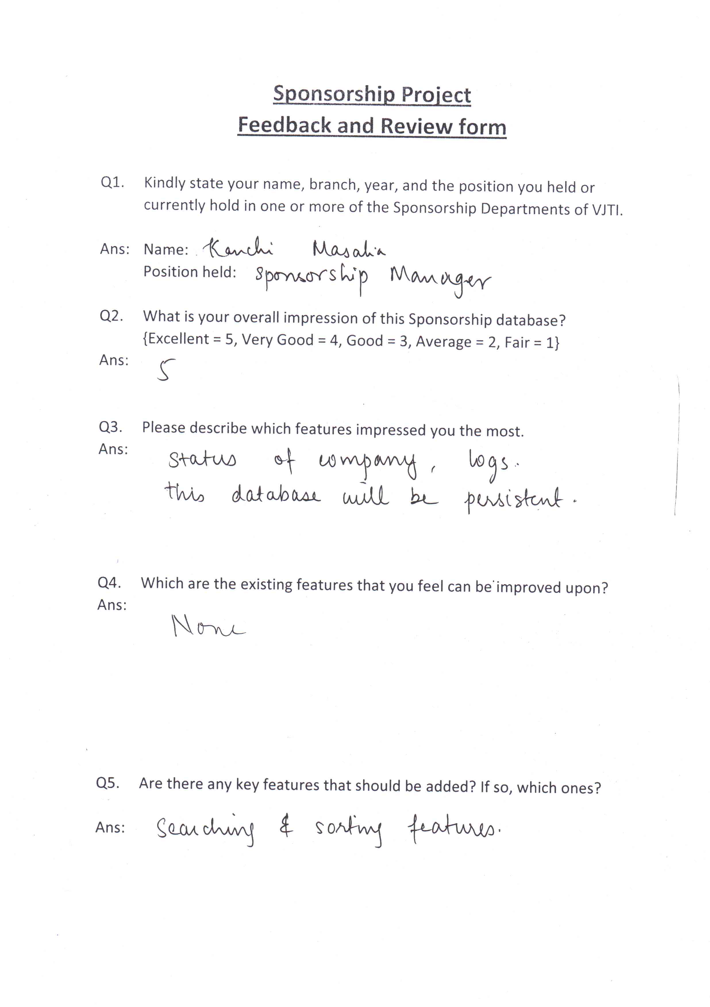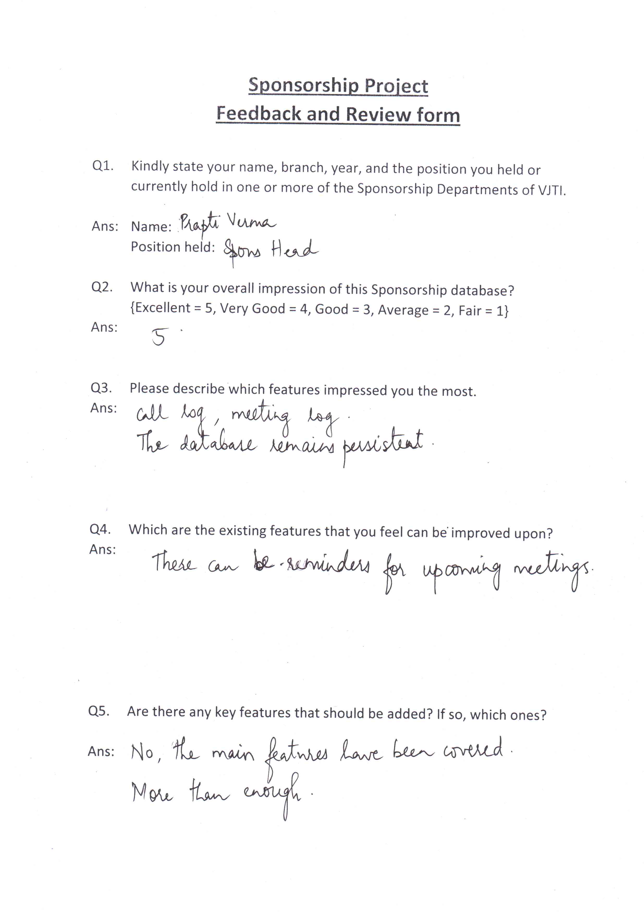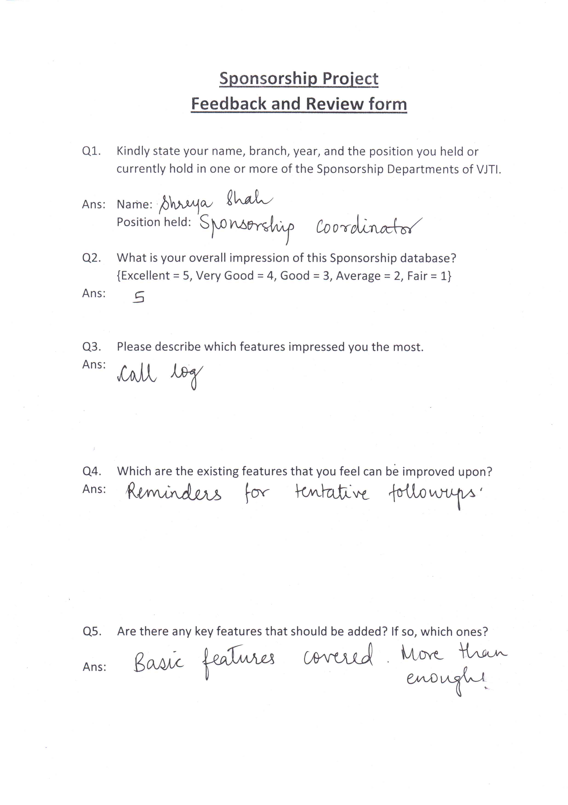

SponsRep:

